INTERNATIONAL
SYMPOSIUM ON TRADITIONAL
TURKISH BOHÇAS

Research title
First Author
Second Author
Third Author
Abstract
Abstract abstract abstract abstract abstract abstract abstract abstract abstract abstract abstract abstract abstract abstract abstract abstract abstract abstract abstract abstract abstract abstract abstract abstract abstract abstract abstract abstract abstract abstract abstract abstract abstract abstract abstract abstract abstract abstract abstract abstract abstract abstract abstract abstract abstract abstract abstract abstract abstract abstract abstract abstract abstract abstract abstract abstract abstract abstract abstract abstract abstract abstract abstract abstract abstract abstract abstract abstract abstract abstract abstract abstract abstract abstract abstract abstract abstract abstract abstract abstract abstract abstract abstract abstract abstract abstract abstract abstract abstract abstract abstract abstract abstract abstract abstract abstract abstract abstract abstract abstract abstract abstract abstract abstract abstract abstract abstract abstract abstract abstract abstract abstract abstract abstract abstract abstract abstract abstract abstract abstract abstract abstract abstract abstract abstract abstract abstract abstract abstract abstract abstract abstract abstract abstract abstract abstract abstract abstract abstract abstract abstract abstract abstract abstract abstract abstract abstract abstract abstract abstract abstract abstract abstract abstract abstract abstract abstract abstract. abstract abstract abstract abstract abstract abstract abstract abstract abstract abstract abstract abstract abstract abstract abstract abstract abstract abstract abstract abstract abstract abstract abstract abstract abstract abstract abstract abstract abstract abstract abstract abstract abstract abstract abstract abstract abstract abstract abstract abstract abstract abstract abstract abstract abstract
Keywords: Keyword 1, Keyword 2, Keyword 3, Keyword4, Keyword 5.

ULUSLARARASI
GELENEKSEL TÜRK BOHÇALARI
SEMPOZYUMU

Bildiri Başlığı
Özet
Özet özet özet özet özet özet özet özet özet özet özet özet özet özet özet özet özet özet özet özet özet özet özet özet özet özet özet özet özet özet özet özet özet özet özet özet özet özet özet özet özet özet özet özet özet özet özet özet özet özet özet özet özet özet özet özet özet özet özet özet özet özet özet özet özet özet özet özet özet özet özet özet özet özet özet özet özet özet özet özet özet özet özet özet özet özet özet özet özet özet özet özet özet özet özet özet özet özet özet özet özet özet özet özet özet özet özet özet özet özet özet özet özet özet özet özet özet özet özet özet özet özet özet özet özet özet özet özet özet özet özet özet özet özet özet özet özet özet özet özet özet özet özet özet özet özet özet özet özet özet özet özet özet özet özet özet özet özet özet özet özet özet özet özet özet özet özet özet özet özet özet özet özet özet özet özet özet özet özet özet özet özet özet özet özet özet özet özet özet özet özet özet özet özet özet özet özet özet özet özet özet özet özet özet özet özet özet özet özet özet özet.özet özet özet özet özet özet özet özet özet özet özet özet özet özet özet özet özet özet özet özet özet özet özet özet özet özet özet özet özet özet özet özet özet özet özet özet özet özet özet özet özet özet özet özet özet özet özet özet özet özet özet özet özet özet özet özet özet özet özet özet özet özet özet özet özet özet özet özet özet özet özet özet özet özet özet özet özet özet özet özet özet özet özet özet özet özet özet özet özet özet özet özet özet özet özet özet özet özet özet özet özet özet özet özet özet özet özet özet özet özet özet özet özet özet özet özet özet özet özet özet özet (300 kelime)

Anahtar Kelimeler: Anahtar Kelime 1, Anahtar Kelime 2, Anahtar Kelime 3, Anahtar Kelime 4, Anahtar Kelime 5

FIRST DEGREE HEADING
Text text text text text text text text text text text text text text text text text text text text text text text text text text text text text text text text text text text text text text text text text text text text text text text text text text text text text text text text text text text text text text text text text text text text text text. text text text text
Text text text text text text text text text text text text text text text text text text text text text text text text text text text text text text text text text text text text text text text text text text text text text text text text text text text text text text text text text text text text text text text text text text text. Text text text text text text text text text text text text text text text text text text text text text text text text text text text text text text text text text text text text text text text text text text text text text text text text text text text text text text text text text text text text text text text text text text text.
Text text text text text text text text text text text text text text text text text text text text text text text text text text text text text text text text text text text text text text text text text text text text text text text text text text text text text text text text text text text text text text text. Text text text text text text text text text text text text text text text text text text text text text text text text text text text text text text text text text text text text text text text. Text text text text text text text text text text text text text text text text text text text text text text text text text text text text text text text text text text text text text text text text text text text text text text text text text text text text text text text text text text text text text text text text text text text text.

Second Degree Heading
Text text text text text text text text text text text text text text text text text text text text text text text text text text text text text text text text text text text text text text text text text text text text text text text text text text text text text text text text text text text text text text text.
Text text text text text text text text text text text text text text text text text text text text text text text text text text text text text text text text text text text text text text text text text text text text text text text text text text text text text text text text text text text text text text text.

Third Degree Heading
Text text text text text text text text text text text text text text text text text text text text text text text text text text text text text text text text text text text text text text text text text text text text text text text text text text text text text text text text text text text text text text text. Text text text text text text text text text text text text text text text text text text text text text text text text text text text text text text text text text text text text text text text text text text text text text text text text text text text text text text text text text text text text text text text text.

Fourth Degree Subheading
Text text text text text text text text text text text text text text text text text text text text text text text text text text text text text text text text text text text text text text text text text text text text text text text text text text text text text text text text text text text text text text text. Text text text text text text text text text text text text text text text text text text text text text text text text text text text text text text text text text text text text text text text text text text text text text text text text text text text text text text text text text text text text text text text text text text text text text text text text text text text text text text text text text text text text text text text text text text text text text text text text text text text text text text text text text text text text text text text text text text text text text text text text text text text text text text text text text text text text text text text text text text text text text text text text text text text text text text text text text text text text text text text text text text text text text text text text text text text text text text text text text text text text text text text text text text text text.

Table 1. Incentive Regions in Turkey
İller | Bölge 1 | Bölge 2 | Bölge 3 | Bölge 4 | Bölge 5 | Bölge 6
İller | Ankara | Adana | Balıkesir | Afyonkarahisar | Adıyaman | Ağrı
İller | Antalya | Aydın | Bilecik | Amasya | Aksaray | Ardahan
İller | Bursa | Bolu | Burdur | Artvin | Bayburt | Batman
İller | Eskişehir | Çanakkale | Gaziantep | Bartın | Çankırı | Bingöl
İller | İstanbul | Denizli | Karabük | Çorum | Erzurum | Bitlis
İller | İzmir | Edirne | Karaman | Düzce | Giresun | Diyarbakır
İller | Kocaeli | Isparta | Manisa | Elazığ | Gümüşhane | Hakkari
İller | Muğla | Kayseri | Mersin | Erzincan | Kahramanmaraş | Iğdır
İller |  | Kırklareli | Samsun | Hatay | Kilis | Kars
İller |  | Konya | Trabzon | Kastamonu | Niğde | Mardin
İller |  | Sakarya | Uşak | Kırıkkale | Ordu | Muş
İller |  | Tekirdağ | Zonguldak | Kırşehir | Osmaniye | Siirt
İller |  | Yalova |  | Kütahya | Sinop | Şanlıurfa
İller |  |  |  | Malatya | Tokat | Şırnak
İller |  |  |  | Nevşehir | Tunceli | Van
İller |  |  |  | Rize | Yozgat | Bozcaada
İller |  |  |  | Sivas
Text text text text text text text text text text text text text text text text text text text text text text text text text text text text text text text text text text text text text text text text text text text text text text text text text text text text text text text text text text text text text text text text text text text text text text text text text text text text text text text text text text text text text text text text text text text text text text text text text text text text text text text text text text text text text text text text text text text text text text text text text text text text text text text text text text text text text text text text text text text text text text text text text text text text text text text text text text text text text text text text text text text text text text text text text text text text text text text text text text text text text text text text text text text text.
Text text text text text text text text text text text text text text text text text text text text text text text text text text text text text text text text text text text text text text text text text text text text text text text text text text text text text text text text text text text text text text text text text text text text text text text text text text text text text text text text text text text text text text text text text text text text text text text text text text text text text text text text text text text text text text text text text text text text text text text text text text text text text text text text text text text text text text text text text text text text text text text text text text text text text text text text text.

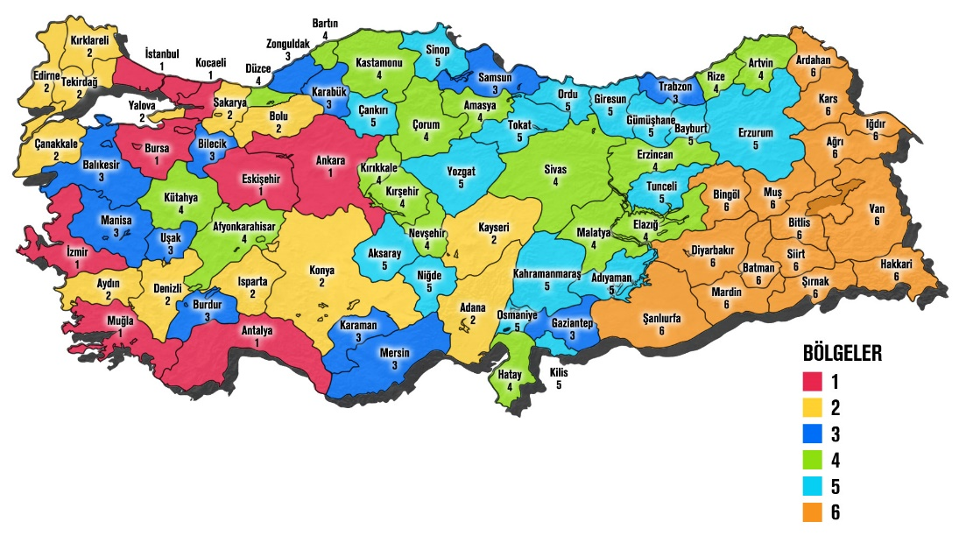
Figure 1. Turkey Incentive Map
Text text text text text text text text text text text text text text text text text text text text text text text text text text text text text text text text text text text text text text text text text text text text text text text text text text text text text text text text text text text text text text text text text text text text text text text text text text text text text text text text text text text text text text text text text text text text text text text text text text text text text text text text text text text text text text text text text text text text text text text text text text text text text text text text text text text text text text text text text text text text text text text text text text text text text text text text text text text text text text text text text text text text text text text text text text text text text text text text text text text text text text text text text text text text. Text text text text text text text text text text text text text text text text text text text text text text text text text text text text text text text text text text text text text text text text text text text text text text text text text text text text text text text text text text text text text text text text text text text text text text text text text text text text text text text text text text text text text text text text text text text text text text text text text text text text text text text text text text text text text text text text text text text text text text text text text text text text text text text text text text text text text text text text text text text text text text text text text text text text text text text text text text text text text text text text text text text text text text text text text text text text text text text text text text text text text text text text text text text text.

REFERENCES
Reference Examples
Single-Author Book
İnalcık, H. (2015). Devlet-i aliyye: Osmanlı imparatorluğu araştırmaları-1. İstanbul: İş Bankası Kültür Yayınları.
Giddens, A. (2009). Sociology. Cambridge: Polity Press.
Single-Author Translated Book:
Freire, P. (2014). Ezilenlerin pedagojisi. (D. Hattaoğlu ve E. Özbek, çev.). İstanbul: Ayrıntı.
Lewis, B. (2000). Modern Türkiye'nin doğuşu (M. Kıratlı, çev.). Ankara: Türk Tarih Kurumu.

Two-Author Book:
Yıldırım Arıcı, A. F. & Ungan, S. (2012). Yazılı anlatım el kitabı. Ankara: Pegem Akademi.
Cook, T. D. & Campell, D. T. (1979) Quasi experimentation: Desing & analysis issues for field setting. Boston: Houghton Mifflin Company.
Two-Author Translated Book:
Cooper, R. & Sawaf, A. (1997). Liderlikte duygusal zekâ. (Çev: Z. Ayman & B. Sancar). İstanbul: Sistem Yayınları.
Three-Author Book:
Köklü, N., Büyüköztürk, Ş. & Çokluk-Bökeoğlu, Ö. (2006). Sosyal bilimler için istatistik. Ankara: Pegem Akademi.
Parris, S. R., Fisher, D. & Headley, K. (2009). Adloescent literacy: Field tested effective solutions for every classroom. Newark: International Reading Assocation.
Edited Book:
Çetin, İ. (Edt.) (2010). Dil ve edebiyat öğretim yöntemleri. İstanbul: Nobel.
Coady, N. & Lehmann, P. (Eds.) (2008). Theoretical perspectives for direct social work practice. New York: Springer.
Book Chapter in an Edited Volume:
Uzun Tulgar, Y. (2010). Edebiyat öğretiminde kullanılan teori ve yaklaşımlar. İ. Çetin (Edt.). Dil ve edebiyat öğretim yöntemleri içinde (s. 45-80). İstanbul: Nobel.
Chapter in a Translated Book:

Creswell, J. (2014). Nicel Yöntemler. S. B. Demir (Ed.), Araştırma Deseni: Nitel, nicel ve karma yöntem yaklaşımları (M. Bursal, Çev.) içinde (s. 155-182). Ankara: Eğiten Kitap.
Piaget, J. (1988). Extracts from Piaget's theory (G. Gellerier & J. Langer, Trans.). In K. Richardson & S. Sheldon (Eds.), Cognitive development to adolescence: A reader (pp. 3-18). Hillsdale, NJ: Erlbaum.
Turkish Article:

Aydın, A. (2004). Psikolojide yeni arayışlar ve insan doğası tartışmaları. Akdeniz Üniversitesi Eğitim Fakültesi Dergisi, 1 (1), 23–29.
Article Published in a Foreign Language:
Winstead Fry, S. & Griffin, S. (2010). Fourth graders as models for teachers: teaching and learning 6+1 trait writing as a collaborative experience. Literacy Research and Instruction, 49(4), 283-298.
Paper Published in a Conference Proceedings:
Arıcı, A. F. & Kaldırım, A. (2013). A solution to the turkey's literacy problem: National reading and writing centers. V. European Conference on Social and Behavioral Sciences. Baltic Institute of Humanities & IASSR. 11-14 September 2014. St. Petersburg, Russia. (s.40-60.)
Paper Not Published in Proceedings or Published as an Abstract:
Arıcı, A. F. & Kaldırım, A. (2013). A solution to the turkey's literacy problem: National reading and writing centers. V. European Conference on Social and Behavioral Sciences. Baltic Institute of Humanities & IASSR. 11-14 September 2014. St. Petersburg, Russia.
Unpublished Graduate Theses:
Arı, G. S. (2003). İşletmelerde güven ve personel güçlendirme ilişkisi: Bankacılık sektöründe bir araştırma. Yayınlanmamış Doktora Tezi. Hacettepe Üniversitesi Sosyal Bilimler Enstitüsü, Ankara.
Kamer, M. (2001). Örgütsel güven, örgütsel bağlılık ve örgütsel vatandaşlık davranışlarına etkisi. Yayınlanmamış Yüksek Lisans Tezi. Marmara Üniversitesi Sosyal Bilimler Enstitüsü, İstanbul.
Evans, T. J. (1996). Elementary teachers’ and principals’ perceptions of principals leadership style and school social organization. Unpublished Doctoral Dissertation. Western Michigan University, Kalamazoo, Michigan.
Dictionary
Türk Dil Kurumu (2005). Türkçe sözlük. Ankara: Türk Dil Kurumu Yayını.
Türk Dil Kurumu (1975). Felsefe terimleri sözlüğü. Ankara: Türk Dil Kurumu Yayını.
Encyclopedia:
Meydan Larousse (1990). Meydan Larousse ansiklopedisi. İstanbul: Meydan Yayınevi.
Report or Other Institutional Documents:
MEB (2009). Milli Eğitim Bakanlığı 2010–2014 Stratejik Planı. Ankara: MEB Yayını.
MoNE (1977). Report by the ministry of national education supervision council. Ankara: MoNE Publications.
Legal Texts Such as Laws, Regulations, and Bylaws:

Milli Eğitim Temel Kanunu (1973). Resmi Gazete. Yayım Tarihi: 24.06.1973. Sayısı: 14574. Numarası: 1739.
Web Address:
UNESCO. (2013). World Heritage list. http://whc.unesco.org/en/list adresinden erişildi. (Erişim Tarihi: 01.05.2013)

Full Name, University, Department or Program, e-mail.
Full Name, University, Department or Program, e-mail.
Full Name, University, Department or Program, e-mail.

